1. Install Required templates from **tem.bat**

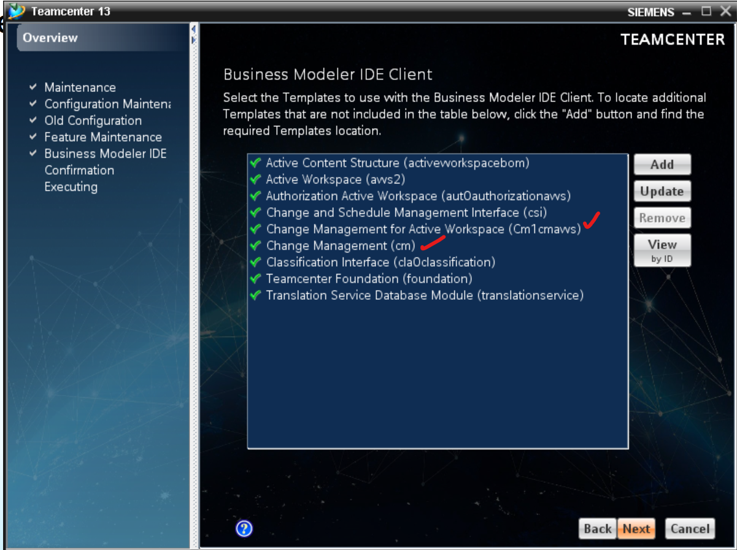

1. Open BMIDE, go to project properties, enable the following templates as shown below:

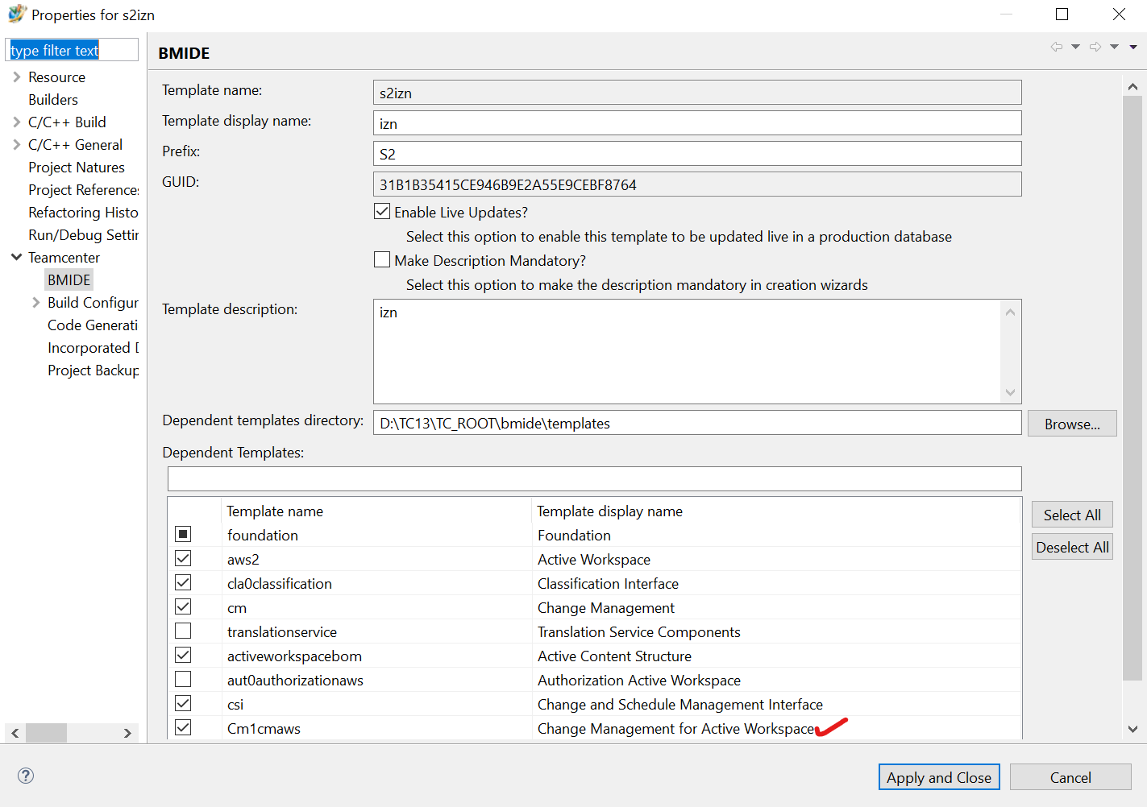

1. Reload the data model.
2. Search for **ChangeItemRevision** object and open properties tab
3. Select **object_desc** and under property constants, provide the value as shown below:

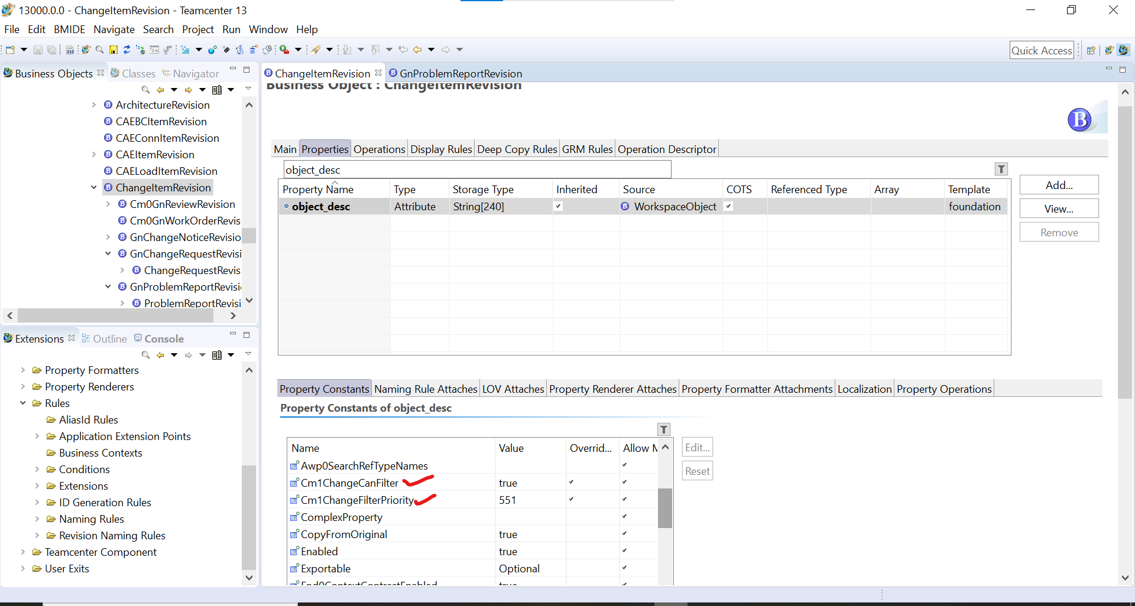

1. Deploy the changes.
2. After this, run the Indexing commands in Admin cmd prompt
   1. D:\TC13\TC_ROOT\solr-8.6.3>TcSchemaToSolrSchemaTransform.bat <space> D:\TC13\TC_DATA\ftsi\solr_schema_files
   2. D:\TC13\TC_ROOT\TcFTSIndexer\bin>runTcFTSIndexer.bat -task=objdata:test
   3. D:\TC13\TC_ROOT\TcFTSIndexer\bin>runTcFTSIndexer.bat -task=objdata:index
   4. D:\TC13\TC_ROOT\TcFTSIndexer\bin>runTcFTSIndexer.bat -task=objdata:sync -interval=25
3. Now, Open the file **Cm1ChangeDashboardPieChartViewModel.json** located at D:\TC13\TC_ROOT\aws2\stage\repo\change\src_native\assets\viewmodel
4. Add the **highlighted parts** of code in the json file as shown below: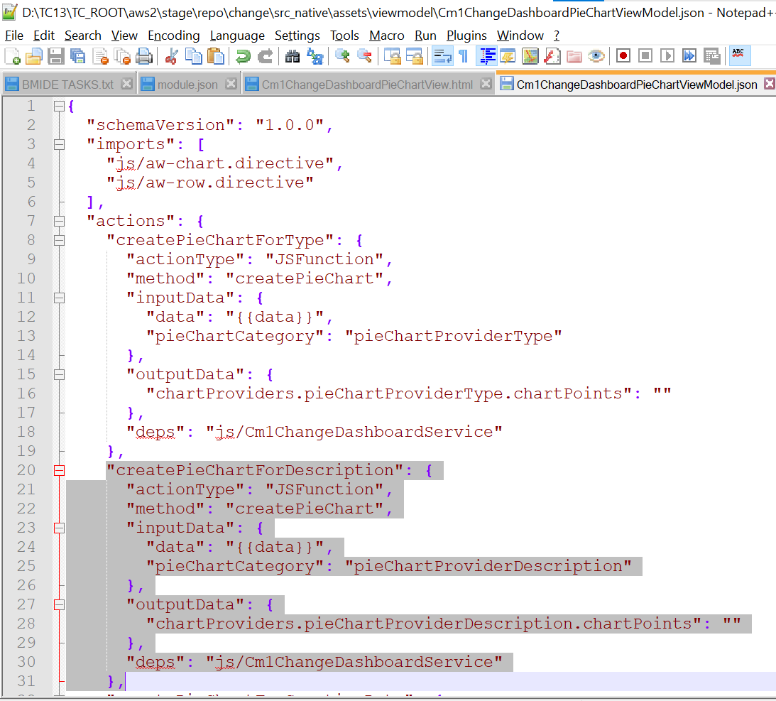



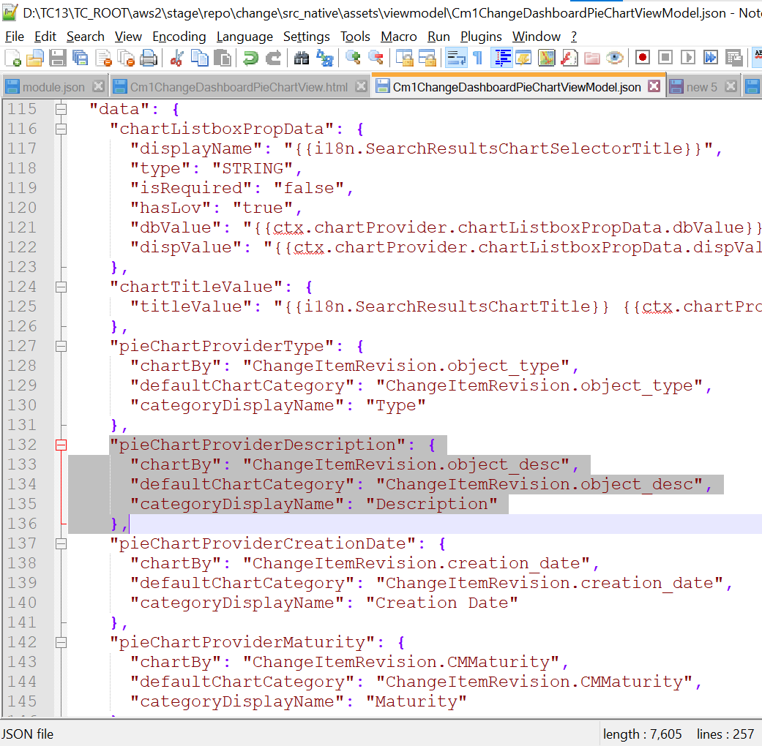

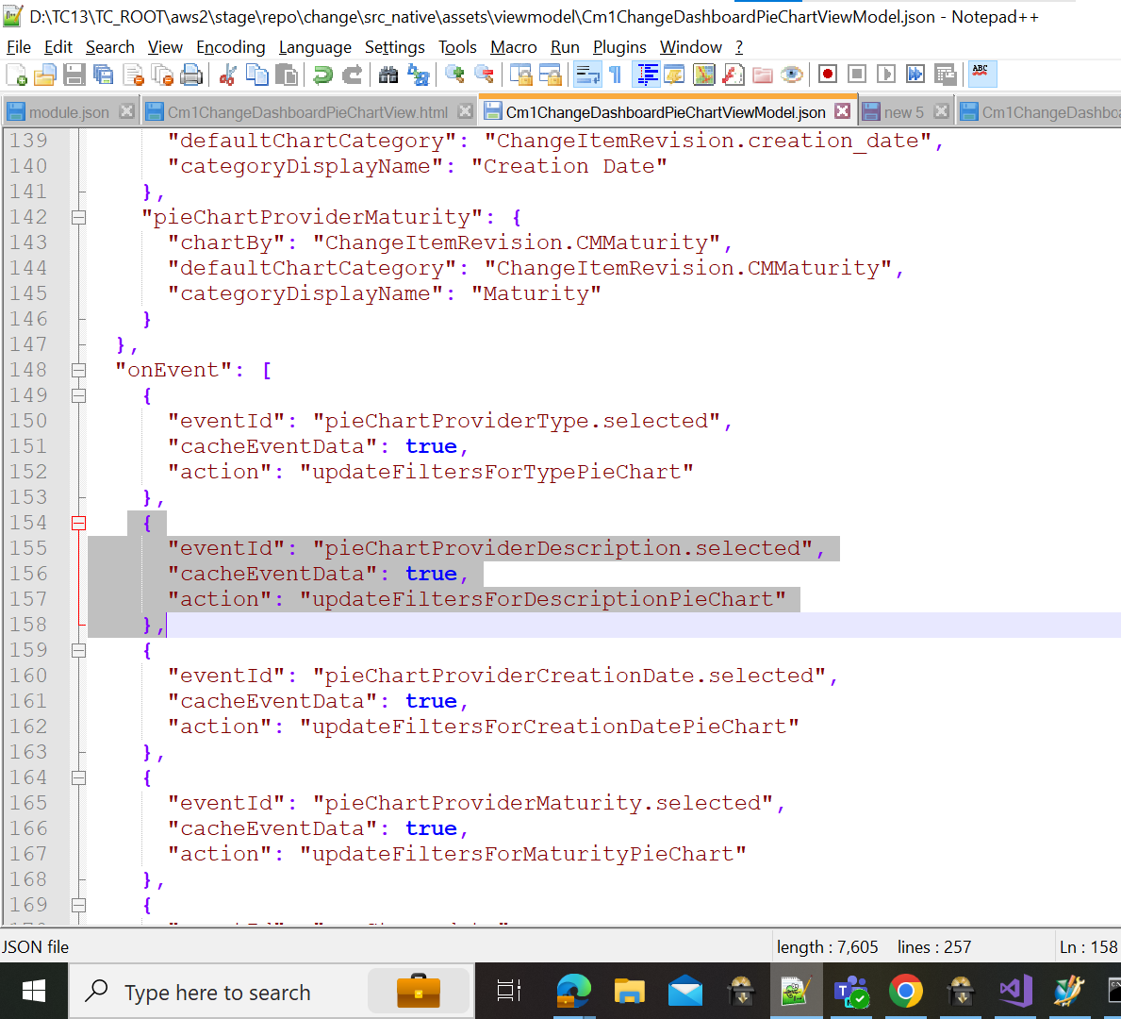

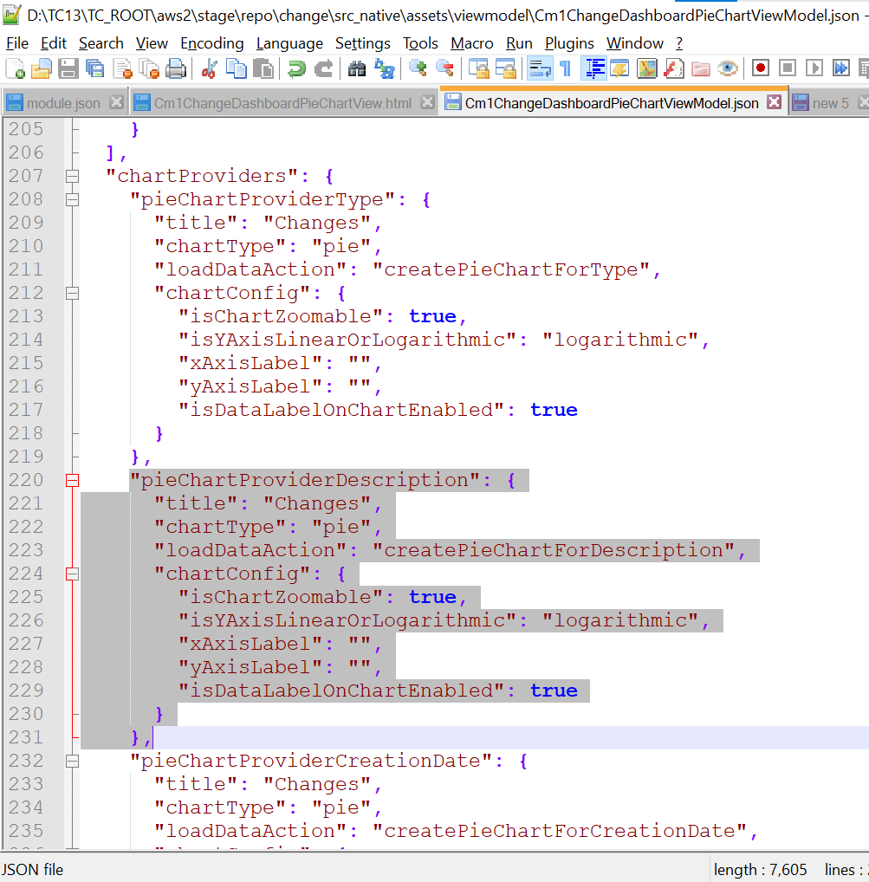

1. Open the **Cm1ChangeDashboardPieChartView.html** located at D:\TC13\TC_ROOT\aws2\stage\repo\change\src_native\assets\html\Cm1ChangeDashboardPieChartView.html
2. Add the highlighted part in the html code as shown below

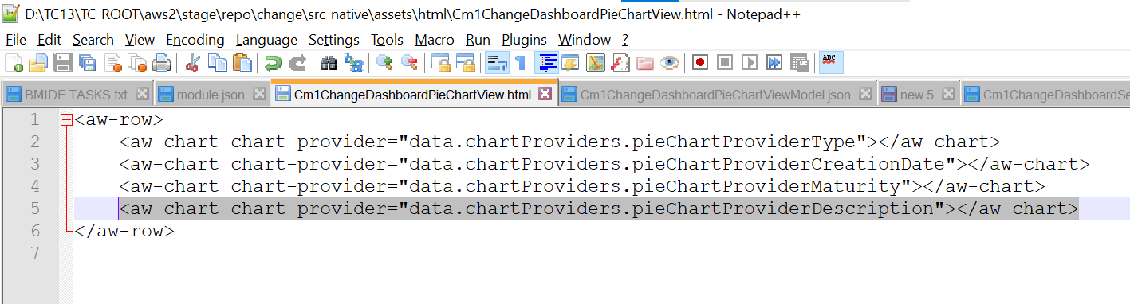

1. Run awbuild.cmd

An extra pie chart will be added for description property in changes dashboard.

